The Church in America is In Decline: A Report from the Front Lines
by Dr. Anthony Horvath
Draft Report (v. 3, January 3, 2017)
Introduction
Christian apologetics is the ‘defense of the Christian faith.’ This defense is usually carried out along intellectual lines, marshalling arguments and evidence to show that Christianity is true; that is, it is reasonable to put one’s faith in Jesus Christ. Apologetics tends to be orientated towards non-believers and has been termed as ‘pre-evangelism.’ The usual purpose of apologetics is to clear away obstacles and address objections so that people are more inclined to hear the Gospel with an open mind and heart.
In 1 Corinthians 3:5-9, Paul wrote:
What then is Apollos? What is Paul? Servants through whom you believed, as the Lord assigned to each. I planted, Apollos watered, but God gave the growth. So neither he who plants nor he who waters is anything, but only God who gives the growth. He who plants and he who waters are one, and each will receive his wages according to his labor. For we are God's fellow workers. You are God's field, God's building.
Within the Church, God has appointed some to plan, others to water, and still others to reap. Christian apologists are appointed to a different task. They arrive at the field while it is filled with thistles and boulders. Their task is to clear away the underbrush, break up the boulders, and carry out the stones. Anyone familiar with this process knows what the next step is: hauling in the manure!
Jesus also called upon agricultural imagery in talking about the mission of the Church.
In Matthew 13, Jesus told his disciples the parable of the sower in which:
A sower went out to sow. And as he sowed, some seeds fell along the path, and the birds came and devoured them. Other seeds fell on rocky ground, where they did not have much soil, and immediately they sprang up, since they had no depth of soil, but when the sun rose they were scorched. And since they had no root, they withered away. Other seeds fell among thorns, and the thorns grew up and choked them. Other seeds fell on good soil and produced grain, some a hundredfold, some sixty, some thirty.
This is a sobering parable. Yet, farmers know that something can be done about the condition of the soil to improve the chances that the ‘good seed’ will fall upon ‘good soil.’ Improving the ‘condition of the soil’ is the kind of work that Christian apologists tend to do. In everything, God gives the growth.
It sounds like so much work! It is. But it was not meant to be this way. When God made the earth, enjoying its fruits was evidently much easier. If it were not so, then the curse that fell upon Adam would not make any sense:
And to Adam he said,
“Because you have listened to the voice of your wife
and have eaten of the tree
of which I commanded you,
‘You shall not eat of it,’
cursed is the ground because of you;
in pain you shall eat of it all the days of your life;
thorns and thistles it shall bring forth for you;
and you shall eat the plants of the field.
By the sweat of your face
you shall eat bread,
till you return to the ground,
for out of it you were taken;
for you are dust,
and to dust you shall return.”
(Genesis 3:17-19)
Just as it was the case that in God’s original design, the ground yielded its pleasures with greater ease, shouldn’t we suppose that in God’s original design, transmitting the faith from one person to another happened with greater ease, as well? If there was once a time when one could eat his bread without breaking a sweat and eating the plants of the field without the pain of dealing with thorns and thistles, was there also a time when one did not need to go out into the field to clear away underbrush, break up the boulders, carry out the stones, and hauling in manure?
Genesis strongly suggests that this is the case in 2:24:
Therefore a man shall leave his father and his mother and hold fast to his wife, and they shall become one flesh.
This is in the first book of the Old Testament. The import and implication of this for transmitting the faith is explained in the last book of the Old Testament, in Malachi 2:15:
Did he not make them one, with a portion of the Spirit in their union? And what was the one God seeking? Godly offspring. So guard yourselves in your spirit, and let none of you be faithless to the wife of your youth.
In other words, one of God’s rationale for making the man and woman ‘one flesh’ was so that there would be ‘Godly offspring.’
Importantly, God’s plan for marriage--and the intrinsic connection with passing on godliness--was established before the fall of Adam.
That means that in the original plan, godly marriages were part of God’s way of producing more godly people. It follows that just as the soil became harder for Adam to work, but was still the main way he would draw sustenance, even though maintaining marriages is harder, it is still the main way to transmit godliness.
As someone who has been involved in Christian apologetics for more than two decades, this is a sobering observation to make, as it means that my most fundamental work is the work I do within my own family. This is my ‘appointed field.’ The reason I have to go into other ‘fields’ is because other mothers and fathers have not done their task, and it falls upon others to step into the gap. Whatever I do in other ‘fields,’ I had better not neglect my own!
The implications go well beyond my work in apologetics. The implications are there for those who ‘plant, water, and reap’ as well. It means that our most foundational efforts are, and will always be, orientated towards our own ‘appointed fields.’ It also means that when we think about the ‘fields’ that have been neglected by others, we should bear in mind that ideally our goal is not to take on those ‘fields’ for ourselves, but to call upon the stewards appointed for those fields to take the task on for themselves.
In making this call, we acknowledge that people may need to be taught how to be stewards. They need to be equipped--not replaced.
The import of this line of reasoning has become increasingly stark for me as I contemplate the current state of the Church, especially as it is manifested in the United States of America. If my analysis is correct, the fundamental way in which God planned for the faith to be transmitted to the next generation was through the happy, healthy, intact union between one man and one woman. While ‘emergency measures’ have been implemented by necessity in order that God may save as many as will be saved, He has not withdrawn this original plan.
Is it possible that there is something about the nature of the institution of the family itself that best facilitates faith transmission? If so, would it follow that the disintegration of that institution would have negatively impact faith transmission? In short, is it the case that the most robust defense of the faith we can make is the one we make to our own families?
In the following analysis, I attempt to make that case.
Preamble
Many Christians have come to the conclusion that the Church in America is in a precarious position. They are right to reach that conclusion. The fact that they are surprised, however, is its own reason for concern. The trajectory has been clear for a long time. There were warning signs all along the path, and writers like G.K. Chesterton (in Eugenics and Other Evils), C.S. Lewis (in The Abolition of Man) and Francis Schaefer (in How Then Should We Live?), to name a few, were sounding the alarm.
But now that we are here, it is important that we understand where it is we actually are, how we got here, and where things are going—and what we can do about it, if anything. Each of these items are huge topics that warrant much investigation and discussion. The purpose of this document is not to speak to each area at length, but rather to highlight important realities that are more relevant than typically recognized in the hopes of directing our deliberations along more fruitful lines. Just as one cannot expect a positive outcome by treating an illness without obtaining a proper diagnosis, first, one cannot expect to alter the current situation without properly diagnosing it.
Where We Are
Many Christians were not particularly pleased with Donald Trump as a candidate, but they much preferred him to Hillary Clinton. Trump’s election was accompanied by the election of Republicans across the country, giving them control over the House, the Senate, the Presidency, very soon the judiciary, and majorities in a majority of the individual United States. Given the fact that the Republicans tend to be more respectful of Christian beliefs and values than Democrats, the 2016 election generated a huge sigh of relief.
It would be a grave mistake, however, to see this as anything more than a reprieve. All of the reasons for being worried still exist. Worse, there is good reason to think they will persist. Worse yet, the American Church might do nothing to capitalize on what might end up being an extremely brief period of safety and security.
To understand why this is this case, it is important to recognize the significance of the rise in what are described as ‘Religious Nones.’ These are people who tell pollsters that they have no religious affiliation. The ‘Nones’ now represent approximately 25% of America’s adult population. That is, 1 out of 4 individuals says they have no religious affiliation.
Astonishingly, only twenty years ago, only about 8% of America’s population said they had no religious affiliation:
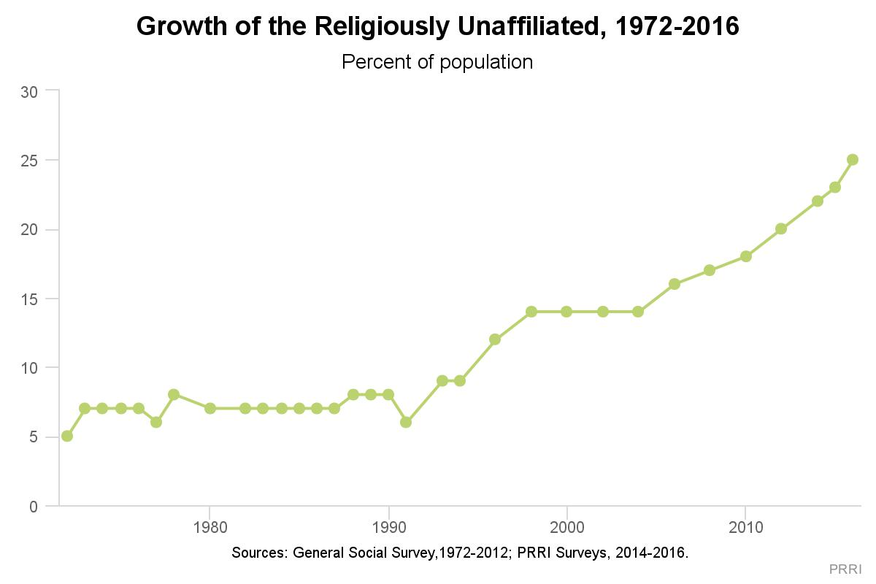

Surely the reader is wondering: “What happened around 1992 to set off a meteoric rise in ‘Religious Nones’?” It can’t be the Internet, as its time was still to come. It can’t be the election of Bill Clinton as president of the United States, as he would only have just then become president. It seems improbable that the most obvious culprit, the education system, could be to blame, as the rise is too sharp, and values and beliefs are not typically turned so abruptly. This is a question we will return to.
Initially, this development, as disturbing as it was, was not seen as being a great cause for concern. After all, there have always been a large number of Americans who did not identify themselves as Christians.
As for those who seemed to be leaving the church, the feeling was that the old patterns would re-assert themselves. People would stop going to church for a time, but they probably wouldn’t leave the faith altogether. When these people finally had kids of their own, they would come to appreciate the value of ‘church’ and return, bringing their children with them.
But, right from the beginning, there were troubling indications that something new was happening.
For example, PEW reported in 2016:
Perhaps the most striking trend in American religion in recent years has been the growing percentage of adults who do not identify with a religious group. And the vast majority of these religious “nones” (78%) say they were raised as a member of a particular religion before shedding their religious identity in adulthood.
In other words, while there have always been atheists and agnostics and others unaffiliated with any religion, as the chart above suggests, their share of the population remained steady. When their share of the population began to skyrocket, it wasn’t because these groups were having more children—it was because the children of Christians, in particular, were leaving the faith. As PEW put it in 2015:
Only about 9% of U.S. adults say they were raised without a religious affiliation, and among this group, roughly half say that they now identify with a religion (most often Christianity). But nearly one-in-five Americans (18%) have moved in the other direction, saying that they were raised as Christians or members of another faith but that they now have no religious affiliation. That means more than four people have become “nones” for every person who has left the ranks of the unaffiliated.
We had them. Then we lost them.
And they aren’t coming back.
Specifically referring to the ‘old pattern’ where people stopped going to church for awhile and then returned, Barry Kosmin, director of the 2013 ARIS National College Student Survey, said, “To the contrary, I believe that a fundamental change has recently occurred in American society and that there has been a significant generational shift away from religion and theism.”
That young people have been leaving the churches in droves and haven’t returned are two things that Christians can see with their own two eyes, and don’t need the help of pollsters to reveal it to them. The fact that Christians have seen these things for themselves is one reason why the American Church is feeling deeply unsettled right now.
As these trends were unfolding, even Christians who noticed them before anyone else and called attention to them found reason to hope. In 2007, Dan Kimball penned a popular book that pointed to a silver lining right in its title: They Like Jesus But Not the Church. That same year, David Kinnaman of the Barna Group released UnChristian: What a New Generation Really Thinks about Christianity. Based on its conclusions and approach, he could have given his book the same title that Kimball gave his book.
Essentially, the argument was that people were ‘turned off’ by Christians but still saw some merit in Christianity. Or, if that is too optimistic, it appeared that people were at least still ‘spiritual’ or ‘religious.’ The prevailing view was that the ‘nones’ were not quite as out of our reach and influence as one might fear.
If that was indeed true (and it certainly may have been in 2007), even this hope seems dashed. As the aforementioned Barry Kosmin said:
The recent growth in the size of the secular population has been fueled by the young Millennial cohort, people born around 1990. It’s important that we know more about how they perceive and approach secularism. One fallacious argument concerning the rise of the “Nones,” as we at the Institute for the Study of Secularism in Society and Culture (ISSSC) have labeled them, has been that many are merely anticlerical and are really religious searchers. They may be disillusioned by organized religion and clergy scandals, but they still remain theistic and will eventually find a compatible religious home. This view explains why investigators at the Pew Research Center have labeled them as religiously “Unaffiliated,” a term that presumes religious affiliation to be the norm. Researchers at Baylor University like to call them “Unchurched,” which presumes even more.
To the contrary, I believe that a fundamental change has recently occurred in American society and that there has been a significant generational shift away from religion and theism. In order to validate this thesis and discover more about its implications, in the spring of 2013 the Center for Inquiry (CFI) partnered with the ISSSC at Trinity College to survey the worldviews and opinions of a national sample of four-year college and university students. In total, over 1,800 students from a sample of thirty-eight universities representing all regions of the United States responded to our online survey.
Thirty-three percent of this young population answered “None” to the question “What is your religion, if any?” This rate far exceeded the 15 to 20 percent recently reported in surveys of the total U.S. adult population. [Emphasis added]
What is encouraging to Barry Kosmin, a secular humanist, does not bode well for the American Church. If his data does indeed correlate with reality—and it almost certainly does—then it means that there is no silver lining to be found in the ascent of the ‘nones’ at all.
On a political level, ‘nones’ are almost always liberal progressives. The Pew Forum reports:
The religiously unaffiliated have become one of the most reliably Democratic constituencies in recent elections. According to national exit polls, 61% of the unaffiliated voted for Al Gore over George W. Bush in 2000. In 2004, John Kerry’s share of the unaffiliated vote increased to 67%. And in 2008, Barack Obama captured fully three-quarters of the vote among the religiously unaffiliated, while 23% voted for John McCain. [emphasis added]
And according to an ARIS report:
Religious students are the most likely to regard themselves “conservative” (34%) compared with 11% of Spiritual and 4% of Secular. Secular students are also the most likely to view themselves as “liberal” (44%) compared with 35% of Spiritual and 17% of Religious. Secular students are also the most likely to describe themselves as “progressive” (20%) compared with 12% of Spiritual and only 5% of Religious.
Here again, the pollsters are only putting numbers behind what Christians have realized all on their own in recent years. As ‘citizens of heaven,’ how temporal affairs play out for the different political parties must be perceived with some indifference. However, insofar as Christians are fully in their rights to pray for a country where we can practice our faith and have the freedom to proclaim the Gospel without the fear of bodily harm (at least not inflicted by the State), the rising support of a political party that is increasingly hostile to both Christians values and Christians themselves is cause for grave concern.
This concern was alleviated by the election results of 2016, but if the trends documented above continue to develop as expected, in 2020 and 2024, Christians will once again be faced with having the hostility towards them once again enshrined within and perpetuated by the State. As will be discussed in the section about ‘where we are going,’ there is good reason to believe that that the American Church will continue its slide into irrelevancy as it is swamped by secularists who likewise continue to entrench their viewpoint, values, and policies, into every nook and cranny of the American experience.
Including, sadly enough, within the Church itself, at the invitation of Christians themselves.
But first, ‘how we got here.’
How We Got Here
Strictly speaking, any analysis of how the Church got where it is today would begin with Adam and Eve’s rebellion. Since it is not practical to recount world history every time one wishes to think about an issue, it is necessary to find a more suitable starting point. There are usually many options, and it is no different in this case. However, if one has too narrow of a starting point, then it is possible or even probable that no progress will be made at all.
Natural places to begin documenting our path to the present situation (since we’re not going to start with Adam and Eve!) would include the Reformation, the ‘Enlightenment,’ or even the Industrial Age. These are too broad. The influence of the Internet would be too narrow. While the ‘democratization of information’ has certainly had a big impact, the trends in question began before the Internet became a ‘big’ thing.
For the purposes of this essay, we will begin our journey with the publication of The Origin of the Species by Charles Darwin, in 1859.
The acceptance of Darwinism prompted a sea change in Western Civilization. The prevailing viewpoint before Darwin was that, somehow and in some way, humans were made in the image of God. After Darwin, humans were seen as no more than animals who were themselves recently descended from pond scum. This change generated whole new ways of looking at the world, inspiring a slew of ‘-isms’ that shared in common a materialistic lens through which to view the world. But one development was especially profound: the conviction that Darwin had given us a ‘scientific’ explanation that was beyond all reason and doubt, while the idea that people were made in the image of God was merely religious sentiment.
It plays out like this: Obviously, public universities and schools should focus on the undeniable and indisputable facts of nature, and not religious doctrines. Obviously, one ought not try to impose one’s ‘religious views’ on the rest of society, especially when religion is essentially nothing more than one’s opinions. Just as obviously, if humans are merely the happy results of happenstance events, one is likewise free to re-think what human society ought to be like—‘free’ within the strict parameters of an atheistic framework, that is. This is the general attitude which dominates the secular mindset.
It did not take long before the ‘traditional’ understanding of marriage and family was relegated into the realm of opinion and preference, that is, fantasy and fiction. In contrast to this, the ‘enlightened’ members of society would regard people as animals and consider new ways to re-construct societal constructs, and these new constructs were understood to be in the realm of fact.
A good summary illustration of this attitude is found in a quote by a former Christian named John Loftus:
Science proceeds according to methodological naturalism, an approach which presumes for the sake of empirical inquiry that everything we experience, if it has a cause at all, has a natural cause. Paul Kurtz defined it as well as anyone when he wrote that it is a “principle within the context of scientific inquiry; i.e., all hypotheses and events are to be explained and tested by reference to natural causes and events. To introduce a supernatural or transcendental cause within science is to depart from naturalistic explanations.”
This is what defines us as modern people. In the modern world all educated people apply methodological naturalism in a vast number of areas. […]. Indeed, Christians today typically assume that there is a natural explanation when they hear a noise in the night, have a stillborn baby, witness a train wreck, or fall ill.
What does any of this have to do with the rise of the ‘religious nones’ and the decline of the Church in America?
In the first place, a great many non-believers themselves cite Evolutionary Theory as one of their reasons for leaving Christianity. It isn’t just the theory, mind you. Given the fact that there are people who are genuinely Christian but still accept some aspects of Evolutionary Theory, there must be more to the story.
The ‘more’ to the story surfaces when young people begin comparing what they’ve learned about Christianity with what they’ve learned in school. One especially big example (according to the ‘nones’ themselves) is the Christian Church’s historic opposition to homosexual behavior. Given the impression that they’ve received about Christianity, they see this opposition as merely ‘religious’ in nature. That is, it is only one’s opinions. They reason that since there cannot be any factual basis for opposing homosexuality, that only leaves bigotry. Finding many Christians refusing to bend, and not wanting to be associated with ‘bigots,’ they leave their church, and never return.
Ironically, it appears that this impression is most pronounced with those who have participated in a church’s educational programs.
As the trends described in this article were becoming apparent, Ken Ham, an unabashed supporter of ‘young earth creation,’ commissioned a study to investigate the beliefs of those who were not Christians. The study found:
In our survey of 1,000 20-somethings who regularly attended church as children and teens [and are no longer attending church; eg, the ‘religious nones’], we asked the question “Did you often attend Sunday school?” In reply, 61 percent said yes; 39 percent said no.”
It seemed as though the more one went Sunday school, the less likely they were to remain in the faith!
If you are a Christian leader and that sentence doesn’t make your blood run cold, you may want to read Ham’s book, Already Gone, where this is more thoroughly documented.
Ham submits that the explanation for this phenomena is that young Christians who attended Sunday School and went to the local public school felt the contrast between ‘fact’ and ‘opinion’ much more dramatically than those who only went to the public school. Anecdotally, this comports with this author’s experience engaging with non-believers.
Most of the authors and researchers who have investigated the rise of the ‘nones’ have noted their disdain for those who oppose ‘gay marriage.’ People who take the Christian scriptures seriously, as written, know that they cannot be reconciled with homosexual behavior, notwithstanding the possibility that the case could be put forward more productively. Clearly, this is a stumbling block to many at the present time. However, it must be understood that the larger issue is the belief that opposition to homosexual behavior is itself arbitrary and capricious, with no foundation possible besides bigotry. And this larger belief is facilitated significantly by the prevailing view that Darwinism, and naturalism more generally, has basically disproved Christianity.
As might be expected, Ken Ham, as a young earth Creationist, puts the weight of his argument on the acceptance of Darwinism. It should be clear from the foregoing that this author believes that much of that emphasis is appropriate. However, Darwinism essentially ‘owned’ the debate for over a century, and while there was a discernible erosion of Christianity in America in that time, the steep drop in Church attendees, and the equally steep rise in the ‘religious nones,’ did not occur until the 1990s.
What triggered this event?
One might say that the ‘law’ finally caught up with the wide-spread acceptance of a Darwinian-grounded secularism, finally impinging on an area of faith-formation and faith-transmission that was more important than many people realized at the time. Indeed, it is because many Christians don’t understand the connection even still today that this report is being submitted.
In the years leading up to the 1990s, there were two other important trends in development. These are visible in this single chart:
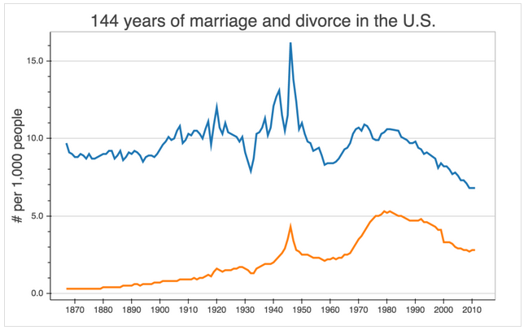
(The blue line represents marriage rates and the orange line represents divorce rates. Source: http://www.usnews.com/news/blogs/data-mine/2015/10/26/marriage-and-the-growing-class-divide [accessed 12/12/2016])
One can see that since 1970, marriage rates have dropped as precipitously as divorce rates rose. The fact that the divorce rate hasn’t continue to rise is probably due to the fact that fewer people are marrying in the first place, and those that do are more likely to value it.
Here is the chart above overlaid on top of the ‘religious none’ chart above:
While the cultural respect for marriage as an institute was severely undermined by the ‘sexual revolution’ of the 1960s, the legal result of this, ‘no fault divorce,’ which swept the country in the 1970s, was probably the single greatest catalyst for the drop in marriages and (obviously) the rise in divorces. But it also provides a tantalizing clue as to what happened around 1992 to light the fire underneath the rise of the ‘religious nones.’
The decade of the 1990s is almost the exact same time that the first children born under the ‘no fault divorce’ paradigm would themselves come to age, graduate from high school, go to college, and then begin thinking about finding a mate. But why should we think that these developments should have anything to do with the rise of the ‘nones’?
We might answer that to begin with by referring to the Christian Scriptures once again, in particular, Malachi 2:15-16 which reads:
Did he not make [the man and woman] one, with a portion of the Spirit in their union? And what was God seeking? Godly offspring. So guard yourselves in your spirit, and let none of you be faithless to the wife of your youth. For the man who does not love his wife but divorces her, says the LORD, the God of Israel, covers his garment with violence, says the LORD of hosts. So guard yourselves in your spirit, and do not be faithless.
In a culture that has decided that the Scriptures do not represent authentic revelation from God reflecting reality as it really is, or further, perhaps, that the Scriptures are human fabrications, this idea that God created the institution of marriage as a means for transmitting the faith to the next generation will be perceived as a mere article of faith. That is, mere opinion.
This viewpoint is latent even within the Church, which tends to see ‘marriage’ and ‘divorce’ as social issues that have little or nothing to do with the business of the Church. As some might put it, the Church’s job is to ‘preach the Gospel,’ not get bogged down with ‘waiting tables.’ If, however, the institution of marriage is God’s very own, specially designed mechanism for propagating the faith, then several things follow.
In the first place, it means that God has purposefully designed ‘marriage’ as a way to create ideal conditions for young people to hear the Gospel, accept it, and live it. It is God’s way to cultivate ‘good soil’ to go along with the ‘good seed’ that is the ‘good news.’ Since the idea of ‘union’ or ‘one flesh’ invoked in Malachi itself harkens back to Genesis 2, before sin even entered the world, and Jesus personally re-affirmed it by quoting it (Matthew 19) it would seem that God’s plan for marriage, including the goal of creating “Godly offspring,” stands to this day as part of the ‘order of creation’ itself. Thus, the ‘ministry of the word’ undermines its own efforts if it ignores the issue of marriage.
In the second place, if the ‘soil’ becomes polluted or overrun with thorns and weeds, then obviously it will be harder for the ‘good seed’ to take root, grow, and multiply. Hence, a generation that is packed with children growing up in broken homes will, unsurprisingly, be less receptive to the Gospel. These children, in turn, will not likely grow up to create healthy, happy families along God’s design, with the result that their children will be even less receptive than their parents were.
This is probably exactly what we are seeing today, as the children of those who came of age in the 1990s are themselves coming of age.
As one might expect if the Scriptures actually do reflect reality, researchers have noticed the connection between ‘family’ status and religiosity.
From David Kinnaman’s UnChristian: What a New Generation Really Thinks about Christianity:
… it is no exaggeration to say that Busters and Mosaics are fatherless generations. […] Our research consistently underscores this reality: efforts to connect people to God are frequently undermined by the lasting negative influences of absent, abusive, or negligent parents. [pg 139, emphasis added]
From Sticky Faith by Dr. Kara Powell and Dr. Chap Clark:
… our research shows a relationship between this parental support and Sticky Faith. But parental support, while important is not the only way you influence your child. More than even your support, it’s who you are that shapes your kid. […] How you express and live out your faith may have a greater impact on your son or daughter than anything else. [pg 23-24, emphasis added]
From How Families Still Matter: A Longitudinal Study of Youth in Two Generations, by Vern Bengston:
When there has been a parental divorce, the transmission of values from parents to children is weaker. In the divorced LSOG [longitudinal study of generations] families there is little correspondence between the values of parents and those of their children. By contrast, among two-parent families there is a sizable resemblance between the values that parents hold and the values that their children hold. [pg 147, emphasis added]
Then we have this, from Robert Wuthnow, in his After the Baby Boomers: How Twenty-and Thirty-Somethings are Shaping the Future of American Religion:
No matter which age group they are in or whether they have children or not, married men and women are more likely to attend religious services than unmarried men and women. This pattern again underscores the significance for religion of the fact that fewer people are marrying now than they did a generation ago and that those who do marry, marry later. [pg 65]
In September of 2016, the Public Religion Research Institute released a report with the sobering title “Exodus: Why Americans are Leaving Religion—and Why They’re Unlikely to Come Back.” They note:
Previous research has shown that family stability—or instability—can impact the transmission of religious identity. Consistent with this research, the survey finds Americans who were raised by divorced parents are more likely than children whose parents were married during most of their formative years to be religiously unaffiliated (35% vs. 23% respectively).
Rates of religious attendance are also impacted by divorce. Americans who were raised by divorced parents are less likely than children whose parents were married during most of their childhood to report attending religious services at least once per week (21% vs. 34%, respectively). This childhood divorce gap is also evident even among Americans who continue to be religiously affiliated. Roughly three in ten (31%) religious Americans who were brought up by divorced parents say they attend religious services at least once a week, compared to 43% of religious Americans who were raised by married parents.
Given this fairly clear connection between marriage and faith transmission, we may expect that the rise of the ‘religious nones’ is going to also generate a corresponding rise of ‘religiously unaffiliated households.’ If ‘households’ is the right term for the kinds of ‘creative’ arrangements that are becoming prevalent! With fewer children growing up in the ‘traditional’ paradigm, we can expect the children coming of age in the next 20 years to be even more hostile to the faith than people are today.
In conclusion, it would appear that a perfect storm has gathered over the United States. On the one hand, a formidable objection to Christianity has become the prevalent view: Darwinism. And no wonder it has become prevalent—it is taught to young people in every science classroom in virtually every school in America. Including the Christian schools. At the same time, it has become socially acceptable to live one’s life as if Darwin was true (and Christianity is not), including in the specific realm that God had designed for faith-transmission; that is, the family. Thus, at the same time that every child in America is being taught, albeit implicitly, that Christianity is not true, the homes that they are growing up in are increasingly toxic to faith formation.
Why then should we be surprised that the culture is becoming more and more hostile to the Christian faith?
What We Can Do About it
Many of those reading this report are themselves divorced or grew up in a broken home. They may resent being targeted, or perhaps are ashamed that their failures created spiritual wreckage. They may be all too aware of that wreckage.
The purpose of this report is not to accuse or shame. Consider two anecdotes.
First, I (the author of this report) grew up in a fractured home, and know firsthand the kind of damage divorce inflicts upon children, as I was once one of those children. It is ironic, and not coincidental, that I myself fell away from the faith as I came of age, right about 1992. My parents divorced around 1980. Pondering the dynamics of how my disbelief manifested at the end of my formative years, it is clear looking back that my atheism did not arise from overt intention. The trends discussed in this report impacted me, personally, and I can see it in my own life. I have no desire to condemn my own parents but it would not be helpful to future generations to perpetuate the notion that all ‘family structures’ are equal.
Secondly, after a presentation I once gave, a parent came up to me and shared with me the sad story that four of his five children had gone through twelve years of Christian education, but had fallen away. Later that evening, I had a conversation with the fifth child, who confided that he, too, had become an atheist. Here is a case where an apparently healthy, intact, family, where the parents had gone so far as to put every child through private Christian schooling, nonetheless had every one of them fall away from the faith.

There is no silver bullet.
There is no magic formula.
The general rules have many exceptions, because life is a messy affair.

Regardless, life got a whole lot more messy after the 1960s, and we would be foolish not to try to understand what happened and what is happening, especially if we want to try to do something about it.
The purpose of this report is not to criticize or condemn, but to stir churches to action, while there is still hope that action might change the trends. Rather than issue recommendations with a ‘shelf life’ based on circumstances, it is better to look to the fundamentals. In another 20 years, the possible avenues available to the American church might be radically different.
If it is the case that the disintegration of the family coupled with widespread acceptance of a teaching that simultaneously undermines families while undermining the proclamation of the Gospel (Darwinism), then these are the areas where we need to direct our attention.
To begin with, the American church has to come to grips with the fact that society has largely slipped away from them. Great harm to the Church was done via anti-family legislation arising from the 1960s and 1970s, but that itself raises red flags. Why was the fate of the church so intimately bound to secular legislation? Whatever happened in wider society to loosen the marital ties, Christians ought not to have participated. How did society get to a point where anti-family legislation could be passed at all, when American is supposedly a ‘Christian’ nation?
Despite being warned by the likes of Schaefer, Chesterton, and Lewis, various entities worked to change the shape of family life with the Church constantly fighting ‘rear guard’ actions to deal with problems after they had already developed. For example, the rise of the “Moral Majority” in the 1980s would have been better timed if it had occurred in the 1950s and 1960s when activists were deliberately laying the groundwork for dismantling the family. More crucially, counsel and encouragement on the Biblical basis for the institution of marriage, as traditionally understood, ought to have been a core part of the Church’s ministry all along.
Developments like ‘no fault’ divorce did not happen overnight. Dr. Ryan MacPherson of the Hausvater Project has been among the best in researching the liberal progressive effort to enact ‘no fault’ divorce legislation. A vivid illustration of the scope of intrusion on the ‘traditional family’ by those with a secular viewpoint is the so-called ‘Jaffe Memo,’ below.
This memo was sent by a senior member of Planned Parenthood, Frederick Jaffe, to the president of the Population Council, Bernard Berelson, in 1969.
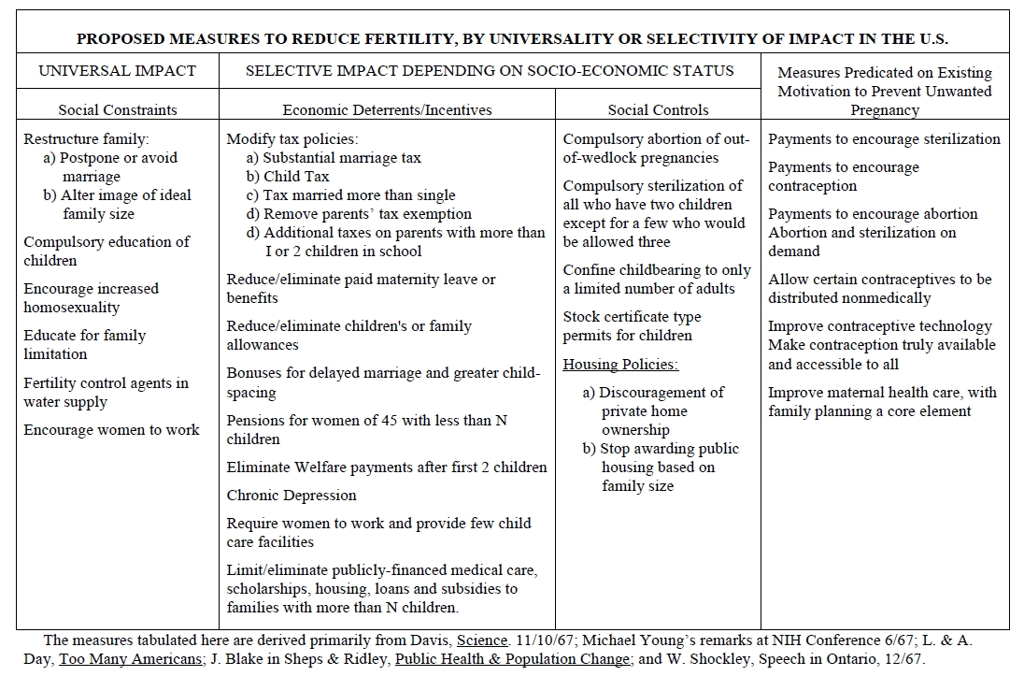

Many of these ideas were incorporated into the Rockefeller Commission Report on Population (1972) and would subsequently become public policy under Richard Nixon, Gerald Ford, and Jimmy Carter.
Space does not allow a full treatment of this topic. I am not suggesting that all of these items were implemented and acted upon. Rather, the above memo serves to illustrate all the different ideas that were on the table for policy analysts. Literally, the first item on the list is “Restructure family.” How is that for imposing one’s views on the rest of society!
People thinking at this level understand that they generally cannot get what they want through coercion. They have to alter attitudes. In the 1960s and 1970s, they set about deliberately to do just that. The Church, in general, failed to see the danger and acted too late. Indeed, much of the secular attack on the family was derived from the acceptance of the Darwinian viewpoint.
Given the importance of intact, healthy, happy marriages to a robust transmission of the faith, Christians cannot remain unaware of these past efforts. Certainly, Christians must guard their own hearts and minds against the manipulations of people who have no interest in furthering a Christian worldview.
Just what constitutes a Christian worldview?
Recall the anecdote above about the Christian father that put all five of his children through Christian schooling, only to have every one of them become atheists. This was a gentleman who delegated his responsibility for raising his children in the faith to a Christian school. He himself seemed to be unaware of the facts of the faith, having little knowledge of what constitutes the Christian worldview or why we are justified in believing the Christian worldview is sound and solid, and actually corresponds to reality. There may have been a time when parents could get away with not being theologically grounded, themselves, deferring to society and the church to ‘fill in the gap.’ This is no longer that time.
In a famous passage in 1 Peter 3:16, Peter exhorts his reader:
... always be prepared to make a defense to anyone who asks you for a reason for the hope that is in you; yet do it with gentleness and respect, having a good conscience, so that, when you are slandered, those who revile your good behavior in Christ may be put to shame.
There is no hint in this text that this exhortation only applies to pastors or Christian educators. There is no suggestion that this exhortation applies only to theologians or professional church workers. No, the exhortation applies to every Christian, in all times, and in all places.
In light of the fact that most of America’s children are soaking up a secular worldview in educational institutions that America’s Christian parents are knowingly subjecting them to, it is imperative that if you are going to turn over the education of your children to other people, you make up the difference at home with an overwhelming Biblical answer to the many questions that your children will have.
That means knowing your Bible intensely. This means becoming well-versed in what is known as ‘Christian apologetics.’ (The word ‘defense’ in the passage from 1 Peter is the Greek word ‘apologia,’ which means ‘defense.’) It is no use pointing out that life is too busy for such study, and arguing that this ‘busy-ness’ is precisely the reason why matters are delegated to teachers and preachers. Peter does not make this exception.
And besides, God himself, in Malachi 2, makes it clear that the child’s own parents are the primary transmitters of the faith. The task may be harder than ever, but it does not for that reason cease to be the Christian parent’s responsibility. In fact, it is almost certainly the case that just because it is so much harder, it is more important than ever that Christian parents take the lead in raising their own children in the faith.
In regards to the aforementioned anecdote about the father of five atheists, it is also worth highlighting another fact that has been noted by researchers and analysts. While it is the case that women tend to be more religious, and more faithful in their church attendance, whether or not a young person remains in the faith is more strongly associated with the father’s religiosity than with the mother’s religiosity:
If both father and mother attend regularly, 33 percent of their children will end up as regular churchgoers, and 41 percent will end up attending irregularly. Only a quarter of their children will end up not practicing at all. If the father is irregular and mother regular, only 3 percent of the children will subsequently become regulars themselves, while a further 59 percent will become irregulars. Thirty-eight percent will be lost.
If the father is non-practicing and mother regular, only 2 percent of children will become regular worshippers, and 37 percent will attend irregularly. Over 60 percent of their children will be lost completely to the church.
Let us look at the figures the other way round. What happens if the father is regular but the mother irregular or non-practicing? Extraordinarily, the percentage of children becoming regular goes up from 33 percent to 38 percent with the irregular mother and to 44 percent with the non-practicing, as if loyalty to father’s commitment grows in proportion to mother’s laxity, indifference, or hostility.
Obviously, we don’t want to marginalize the importance of a mother’s faithfulness. We may expect there to be many exceptions to the rule.
The implications of this for fathers is just as obvious. However, since many of the readers of this present report are more likely to be pastors and church professionals, and not the average Christian father, it is imperative that we find some way to transfer the import of this lesson to the people who need it most. That is to say, it would appear that the most important programs a church could have are not directed towards the youth, or the women of the church, but rather to the men.
This is clearly a challenge, since women are more likely to become involved in church programs and more likely to bring children to Sunday school and other programs. Yet, perhaps the very elements of what makes men more resistant to becoming involved in a congregation might be the very things that make them more effective at transmitting the faith to the next generation. A congregation that takes this seriously (and they ought) might find that they have to utterly re-think how it does ‘church.’
Or, to put the point more directly, if this fact is not taken seriously, in twenty years, there may be little to no ‘church’ left in America to ‘re-think.’
What would a church geared towards men look like, as opposed to how it looks now? Probably, each congregation needs to wrestle with that question, but they will only do so once they come to grips with the situation as it presently stands.

Let’s summarize:

1. The Church in America is in decline, while the number of nonbelievers is in sharp ascent.
2. There are good reasons to believe that this has been precipitated by the disintegration of the ‘traditional family’ and the widespread acceptance of secular viewpoints.
3. Both the disintegration of the ‘family’ and the acceptance of secular viewpoints (such as Darwinism) have been deliberately engineered, with the American Church usually reacting, rather than pre-empting.
4. Not much hope remains for salvaging wider society, but the Church ought to be concerned first of all with its own faithfulness; its lack of faithfulness probably played a large part in the decline of its influence in society in the first place.
5. Encouraging and facilitating happy, healthy, intact families is critically necessary (and God-ordained) for the cultivation of ‘good soil.’
6. In all places and in all times, each Christian is called to be able to defend their faith and explain to skeptics why they have put their hope in Christ. A thorough grounding in theology and ‘apologetics’ is each believer’s responsibility to pursue.
7. Congregations ought to facilitate that grounding. As soon as possible.
8. The role of men in transmitting the faith—or not transmitting the faith—must be taken seriously, and congregations must act accordingly.

Dr. Anthony Horvath is available to present on these and other topics related to Christian apologetics and can be reached at director@athanatosministries.org

http://www.pewresearch.org/fact-tank/2016/08/24/why-americas-nones-left-religion-behind/ [accessed 11/29/2016]
The point is not incidental; secular households have always had smaller family sizes compared to religious households, so the fact that their share of the population has increased dramatically, anyway, is a red flag.
http://www.pewresearch.org/fact-tank/2015/05/13/a-closer-look-at-americas-rapidly-growing-religious-nones/ [accessed 11/29/2016]
https://www.secularhumanism.org/index.php/articles/5283 [accessed 11/29/2016]
https://www.secularhumanism.org/index.php/articles/5283 [accessed 11/29/2016]
Fortunately, secular humanism is a false ideology, and Christianity embodies the truth. So, despite what Kosmin and other secular humanists believe, people really are made in the image of God, and therefore even as atheists they remain vulnerable to ‘The Hound of Heaven.”
http://www.pewforum.org/2012/10/09/nones-on-the-rise-social-and-political-views/ [accessed 11/29/2016]
http://www.trincoll.edu/Academics/centers/isssc/Documents/ARIS_2013_College%20Students_Sept_25_final_draft.pdf [accessed 11/29/2016]
I say ‘attitude’ rather than ‘argument’ because most secularists cannot or won’t articulate their position in this manner, but this is in fact how they behave. Usually, after sufficient probing, they will finally make statements of this sort, revealing the connections between their materialistic worldview and their social and political convictions. Sometimes, this is a revelation to them!
http://infidels.org/library/modern/john_loftus/christianity.html [accessed 12/7/2016]
The Public Religion Research Institute released a report in September of 2016 which discussed reasons given for why people left religion. 60% reported that they left because “they stopped believing in the religion’s teachings.” While still a sizable number, only 29% said they left because of their church’s stance on homosexuality. Why did they stop believing in their religion’s teachings?
Perhaps this idea of “with a portion of the Spirit in their union” is what Paul had in mind in 1 Corinthians 7:14.
A reference to Acts 6, where the apostles make a distinction between the ‘ministry of the word’ and the Church’s ministry to the poor and hungry.
Pages 7-8.
Canada recently ‘updated’ their law so that a child can be properly seen as having up to four adults as his or her ‘parent.’
This is effectively what secular humanists believe ‘secularism’ is: living as if Christianity is not true. This is different than what Christians perceive ‘secularism’ is, in that they think it merely means inserting into society either our more ‘neutral’ views or those views which are shared by most Americans. This difference in perceptions is one reason why Christians don’t understand the hostility they evoke when it comes to issues such as ‘gay marriage.’ Secular humanists reason that since even Christians don’t really live as if Christianity is true when it comes to participating in broader society, their opposition to homosexuality must be rooted in rank bigotry. More examples could be given.
See for example: http://www.ryancmacpherson.com/publications/10-articles/111-from-no-fault-divorce-to-same-sex-marriage-the-american-law-institutes-role-in-deconstructing-the-family.html [accessed 12/12/2016]
For more information about the ‘Jaffe Memo’ see http://jaffememo.com
See for example page 71 of the Pew Research Forum’s 2015 report, “U.S. Public Becoming Less Religious,” which reports that “More women than men say they attend religious services at least once a week (40% vs. 31%). This gender gap is evident among a variety of Christian groups, though not among Mormons.”
http://www.touchstonemag.com/archives/article.php?id=16-05-024-v [accessed 12/12/2016] Bottom line take away from the article: “You cannot buck the biology of the created order.” Note, the author is referencing a study released more than fifteen years ago, outside of the United States. Nonetheless, it is consistent with other findings, and does not appear to be one of the statistical findings that will become ‘dated’ over time.
If men are the most instrumental at transmitting the faith, then the corollary is likely also true, that men are the most instrumental at transmitting disbelief. Hence, the rise of ‘religious nones’ can be expected to accelerate. From The Pew Forum’s ominously titled 2015 Religious Landscape Study, America’s Changing Religious Landscape: Christian Decline Sharply as Share of Population; Unaffiliated and Other Faiths Continue to Grow: As in 2007, women continue to make up more than half of nearly every Christian group. Roughly two-thirds of Jehovah’s Witnesses are women, as are 59% of those who identify with the historically black Protestant tradition, 55% of those in both the evangelical and mainline Protestant traditions and 54% of Catholics and Mormons. Most religiously unaffiliated adults, by contrast, are men. Fully two-thirds of self-identified atheists are men, as are 62% of agnostics and 55% of those who identify religiously as “nothing in particular” and further say that religion is unimportant in their lives. [pg 59] The disproportionate effect that fathers have in influencing the religious views of their children, coupled with the fact that most ‘religious nones’ are men, combined with the fact that their share of the population is rising, suggests powerful demographic headwinds for the Christian Church in America are on their way!

